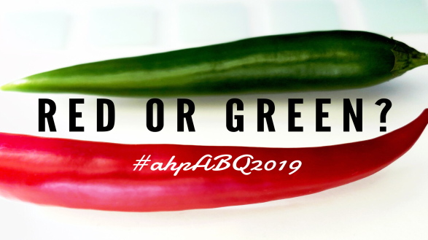
PLEDGE FORM
STUDENT FUND SILENT AUCTION
Auction held at the AHP “High Desert Media Roundup” Conference in Albuquerque, NM, Friday, May 31, 2019

List of items PLEDGED
Suggested items include; equestrian or horse-related gifts, equine-related products or merchandise, New Mexico western-themed items, gift certificates or gift cards. (IMPORTANT - Please indicate estimated value of each item.)
Qty. | Item (Please include a brochure or flyer on each item if available for display purposes) | Value
Name of SUPPORTER Please provide the individual or company to be credited.
NAME

ADDRESS

CITY, STATE, ZIP

PHONE EMAIL

____I plan to ship the items.
PLEASE SHIP PACKAGES to arrive no earlier than
Friday, May 24 and received by Tuesday, May 28.

HOLD FOR ARRIVAL 5/27/19:
Christine Brune, Guest
Hotel Albuquerque at Old Town
800 Rio Grande Blvd. NW
Albuquerque, NM 87104
American Horse Publications Conference
386-290-3253

____I plan to bring items with me.
Complete this form and email before the conference to:
Judy Lincoln, Student Auction Coordinator
ahorsepubs2@aol.com

Please direct any questions to Judy Lincoln at the AHP office at 386-760-7743.
American Horse Publications is a non-profit tax exempt organization classified 501(C) 6. Contributions and purchases are not deductible as charitable contributions. They may be deductible as trade or business expenses if ordinary and necessary in conducting business.

On behalf of American Horse Publications, thank you for your generosity.

